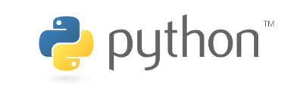An introduction to data science with

Håkon Hapnes Strand

Contents

0. The How, Why and What of Python 1

1. Anaconda distribution 1

2. Jupyter notebook 1

3. Basic Python 1

4. Core data science libraries 2

5. Machine learning 2

6. Natural Language Processing (NLP) 2

# The How, Why and What of Python

* History of Python
* Rise of data science

# Python download and setup

conda list

conda install nb_conda

conda create -n py27 python=2.7 ipykernel

activate py26

Python 2 vs. 3

# Jupyter notebook

A convenient way to prototype and share Python code.

Line/cell magic

%time

%%time

%%timeit

%%javascript

Markdown

# Basic Python syntax

2+2

for, if, while

List comprehension

Dict comprehension

Generators (comprehension)

# Core data science libraries

* Numpy
  + Add two lists, add two np arrays (element-wise)
  + Shapes and linear algebra
  + Dot product
* Pandas
  + Read csv
  + pd.dummies
  + pd.concat
  + mean, max, min
  + df.loc
    - np.where
* statsmodels

# Machine learning

(scikit-learn example)

(talk about TensorFlow/Keras, CNTK, PyTorch)

# Natural Language Processing (NLP)

conda install gensim

conda install nltk

word2vec